# Wiring

|  |  |  |  |  |  |  |
| --- | --- | --- | --- | --- | --- | --- |
| **Signal on ADXL335** | **Plug #1 Color** | **Wire Color** | **Plug #2 Color** | **Jumper Color** | **Arduino Pin#** | **Comments** |
| VCC | Brown | Orange | Brown | Orange | +3.3V |  |
| GND | Red | Green | Red | Green | GND |  |
| X | Orange | White-Orange | Orange | White-Orange | 0 |  |
| Y | Yellow | White-Brown | Yellow | White-Green | 1 |  |
| Z | Green | White-Blue | Green | White-Blue | 2 |  |
| ST | Blue | - | Blue | - | - |  |

# Xbees

**XBee must be removed from the Arduino when programming it, as the Xbee holds open the serial port.**

XBee #1 (On Arduino)

Was 19200 baud (how did it work on Arduino then??)

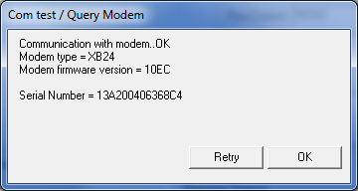

Baud rate is now **38400**. Saved profile to XBee1.pro .

XBee #2 (USB Link to PC)

Was 31250 (MIDI)

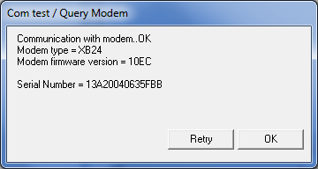

Baud rate is now **38400**. Saved profile to XBee2.pro .